LAB 1: Using INetSim on Kali Linux
Course Name: Malware Analysis and Reverse Engineering (IAM302)
Student Name: Nguyễn Trần Vinh – SE160258
Instructor Name: Mai Hoàng Đỉnh
Lab Due Date: 7/1/2023

Purpose
We will use Kali Linux to simulate the Intenet, and the Windows machine will be fooled by it.

Getting the Virtual Machine 7-Zip Archive Files
The two files you need are:
- Kali Linux 32 bit VM PAE: Kali-Linux-2016.2-vm-i686.7z (or a later version)
- Windows 2008 Server: Win2008-Target.7z

Setting the Kali Linux VM to NAT Networking
- dhclient
- ifconfig
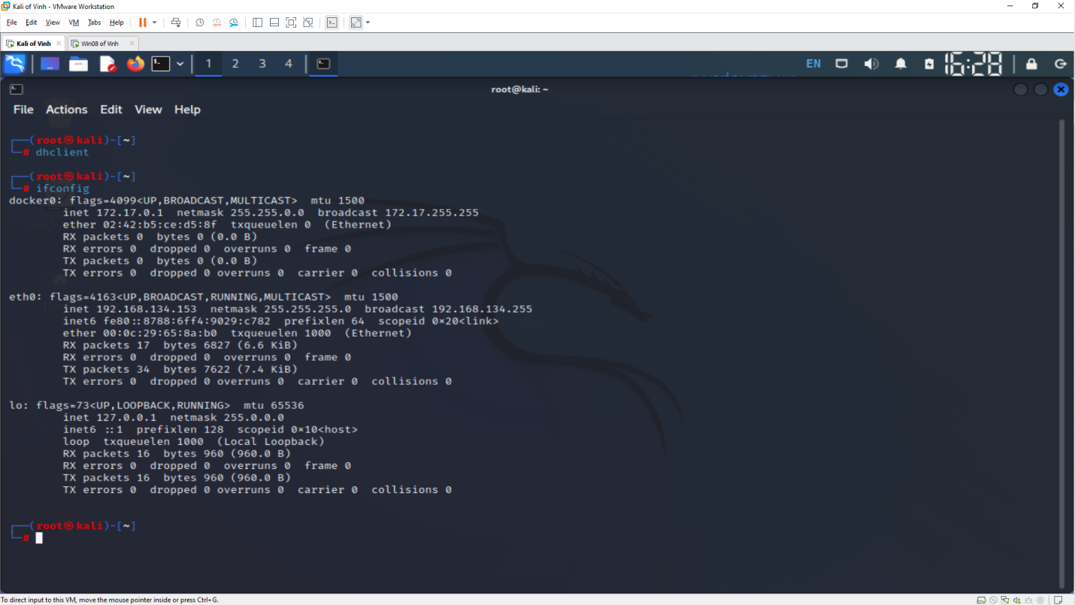

Checking for a Web server
- lsof -i :80
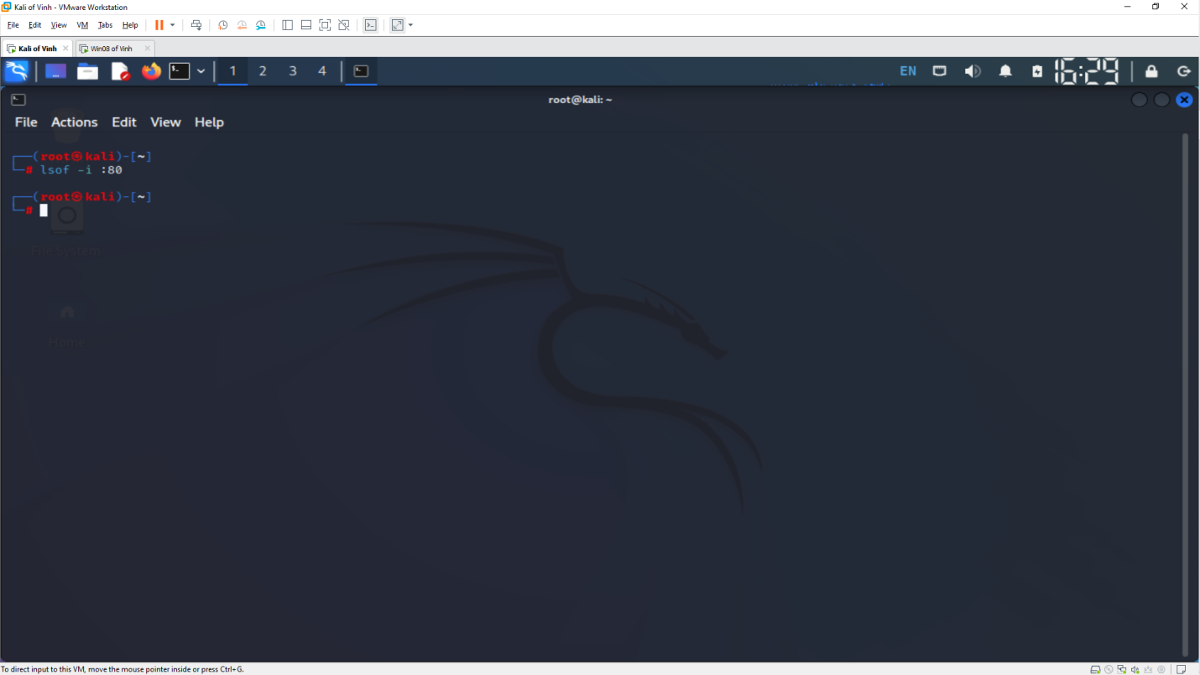
Configuring inetsim
- dns_default_ip
- service_bind_address
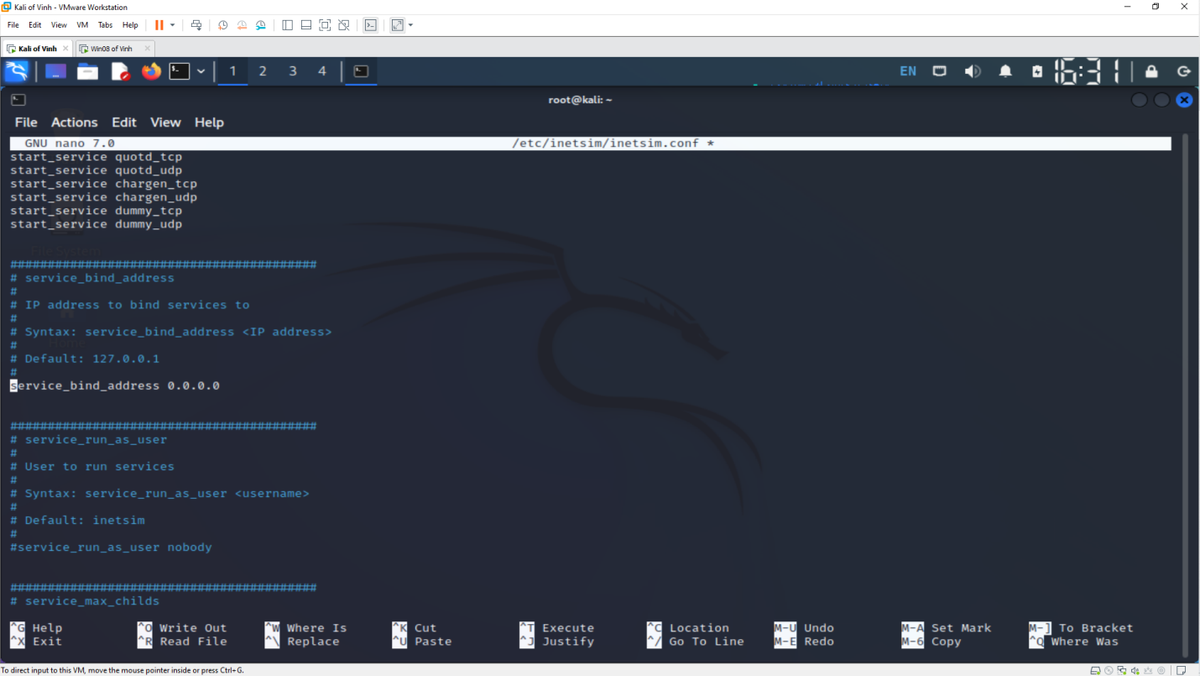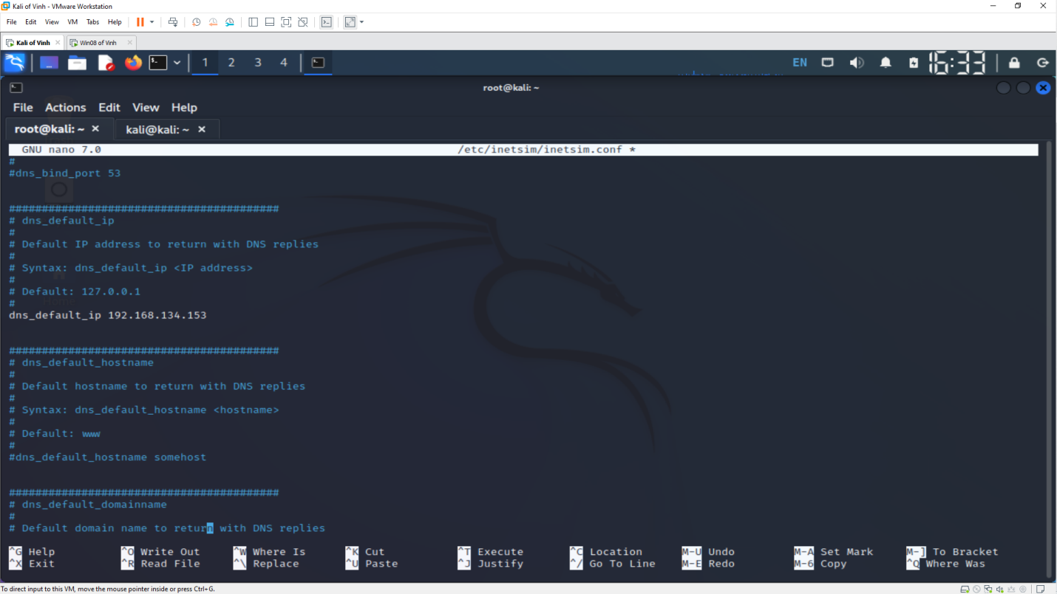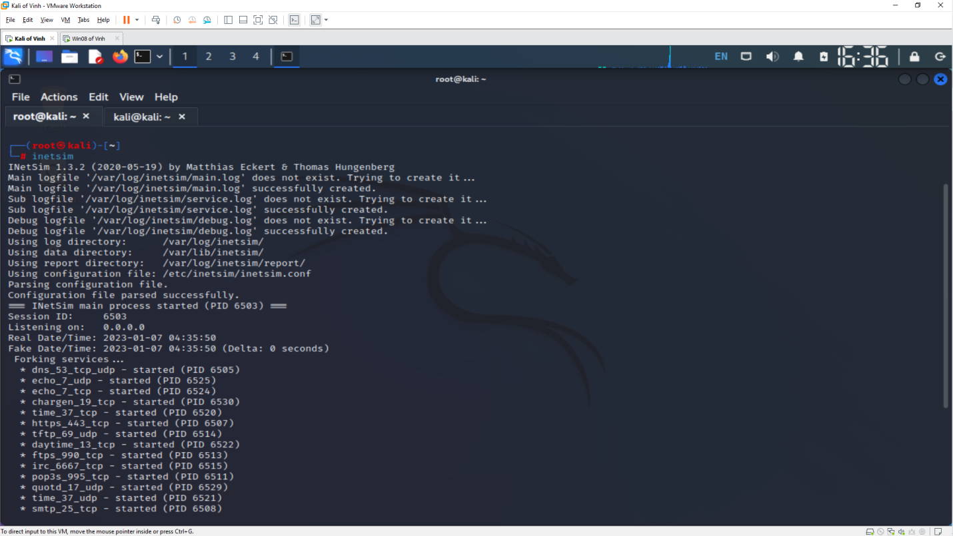
Setting the DNS Server
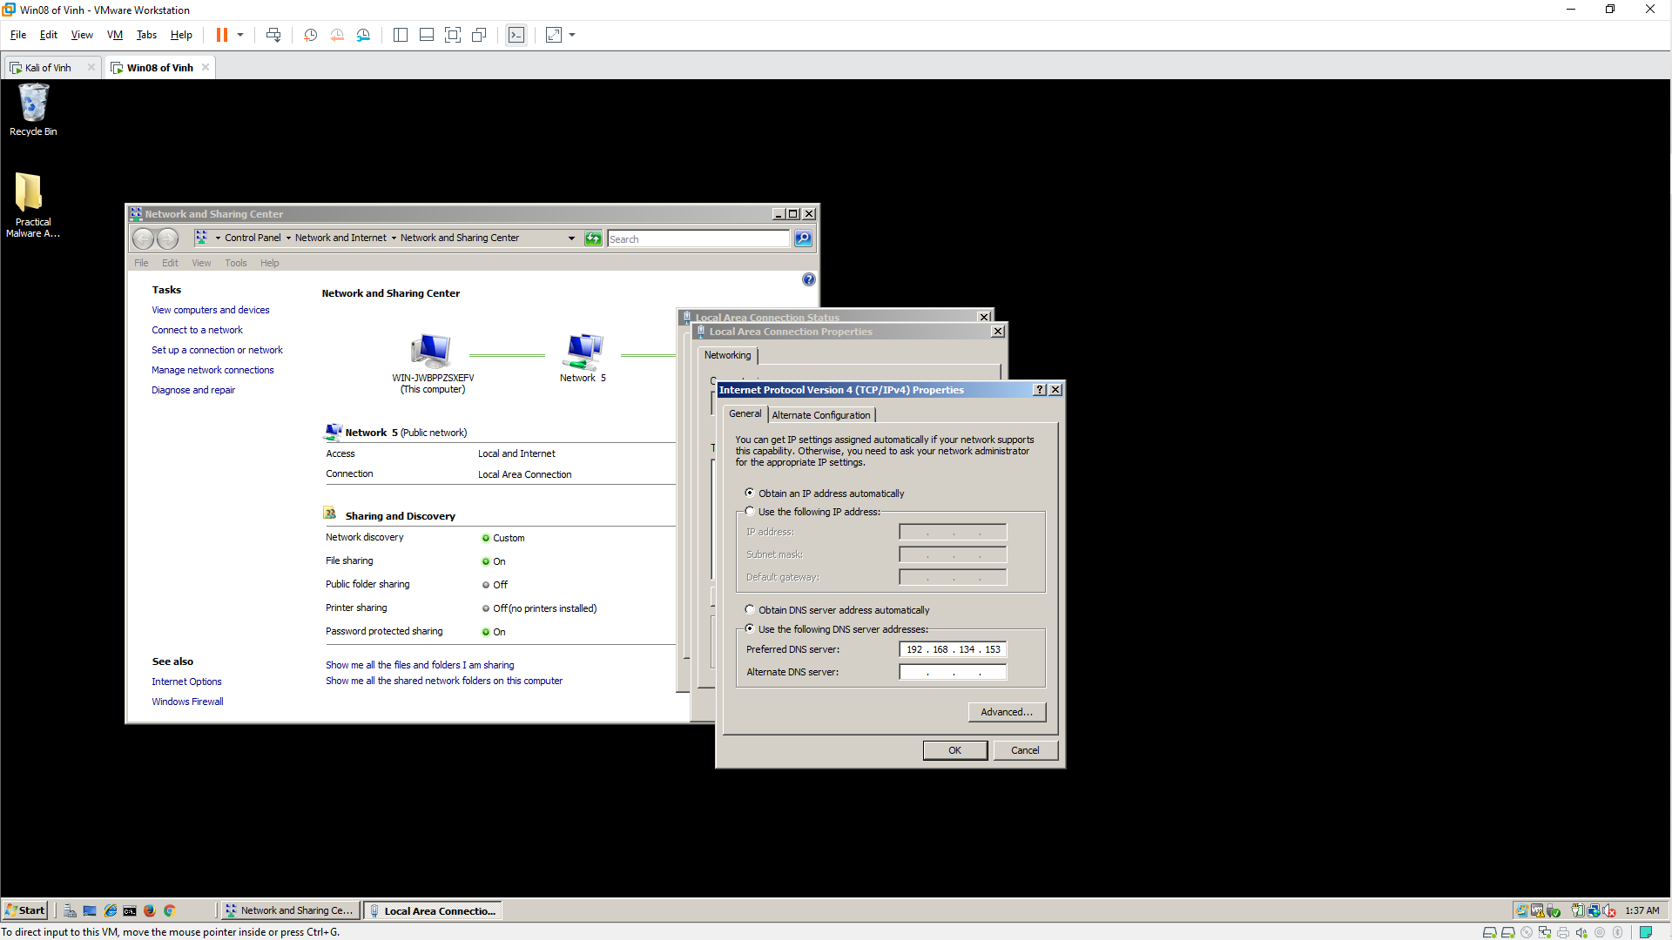

Viewing an HTTP Web Page 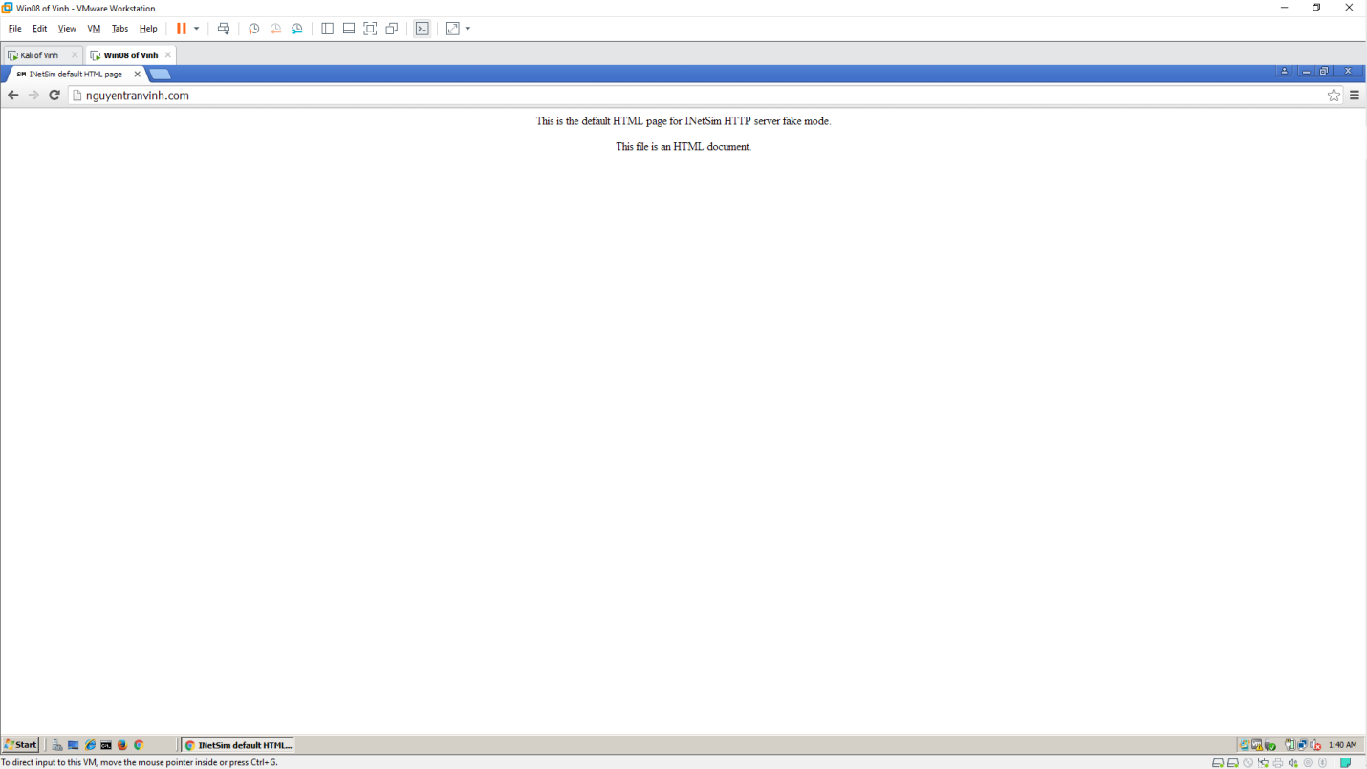

Scanning
